Aim Trainer Project Document

This program will be an aim trainer game, made for the purpose of improving the user’s mouse movement skills through repetition. The program will create targets on screen, and the user must click them as fast as possible. The faster they can click the target, the more points they will earn. If the user hit over 10 targets in a round, then there will be data exported to a database, including the amount of hits made per second. The user will be able to select pre-made difficulties that change the pace of the game to their skill level. There will also be a customisable difficulty option, where the user can change variables such as how many targets appear, and how long a target can exist before a new target is created.

Features

This program will implement
- A web user interface, which is integrated with a mySQL database
- A python software element, which will make use of object-oriented programming
- A standard algorithm to sort scores, so that high scores can be shown

Scope

This program will include
- A completed design
- A functional game
- A web-database

Boundaries

This program will not include

UML Use Case Diagram
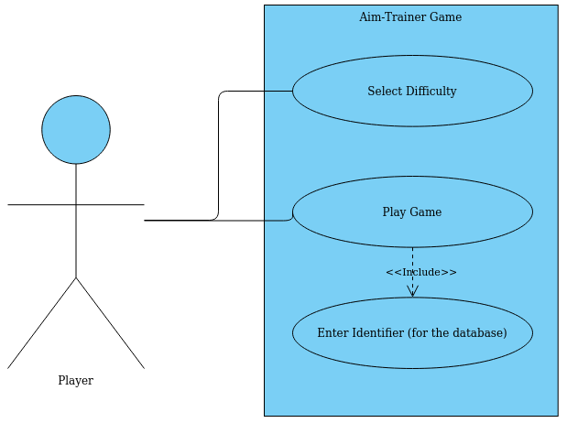

Project Plan

Gantt Chart for James Macdonald – Advanced Higher Computing Science Project Plan
 | 11/09/20 | 11/16/20 | 11/23/20 | 11/30/20 | 12/07/20 | 12/14/20 | 12/21/20 | 12/28/20 | 01/04/21 | 01/11/21 | 01/18/21 | 01/25/21 | 02/01/21 | 02/08/21 | 02/15/21 | 02/22/21 | 03/01/21
1. Analysis
2. Design
3. Implementation
4. Testing
5. Bug fixes and Final Touches
5. Evaluation

Analysis Stage

Analysis will consist of creation of the Analysis document including
1. Description of Problem
2. Identify Advanced Higher concepts and integration
3. Scope
4. Boundaries
5. Requirements Specification for:
a. End-user Requirements
b. Functional Requirements
c. Input Validation

Design Stage

The design stage will simply be creations of wireframes and UML diagrams.

Implementation Stage

Sub-tasks:

3.1 Core Game
3.2 Difficulty Selection
3.3 Track Scores
3.4 Create Database Table
3.5 Create link to Database
3.6 Create sort of Data in Database

Testing Stage

I will combine implementation and testing simulaneously, to maximise efficiency. This is use of an Agile development process.

In practice, this will likely be a process of implementing a design, and then debugging it with means such as watchpoints to ensure the program is successful. If there are no hitches, I will be able to immediately move back to implementing new fixes and features for the program.

